**TT pallet motor**

**1.** **Learning** **objectives**

In this course, we mainly learn to use STM32F103RCT to drive TT code disc motor speed measurement.

**2. Prepare before class**

In the example, we use the TB6612 motor drive module, or we can use other motor drive modules to drive the motor function only.

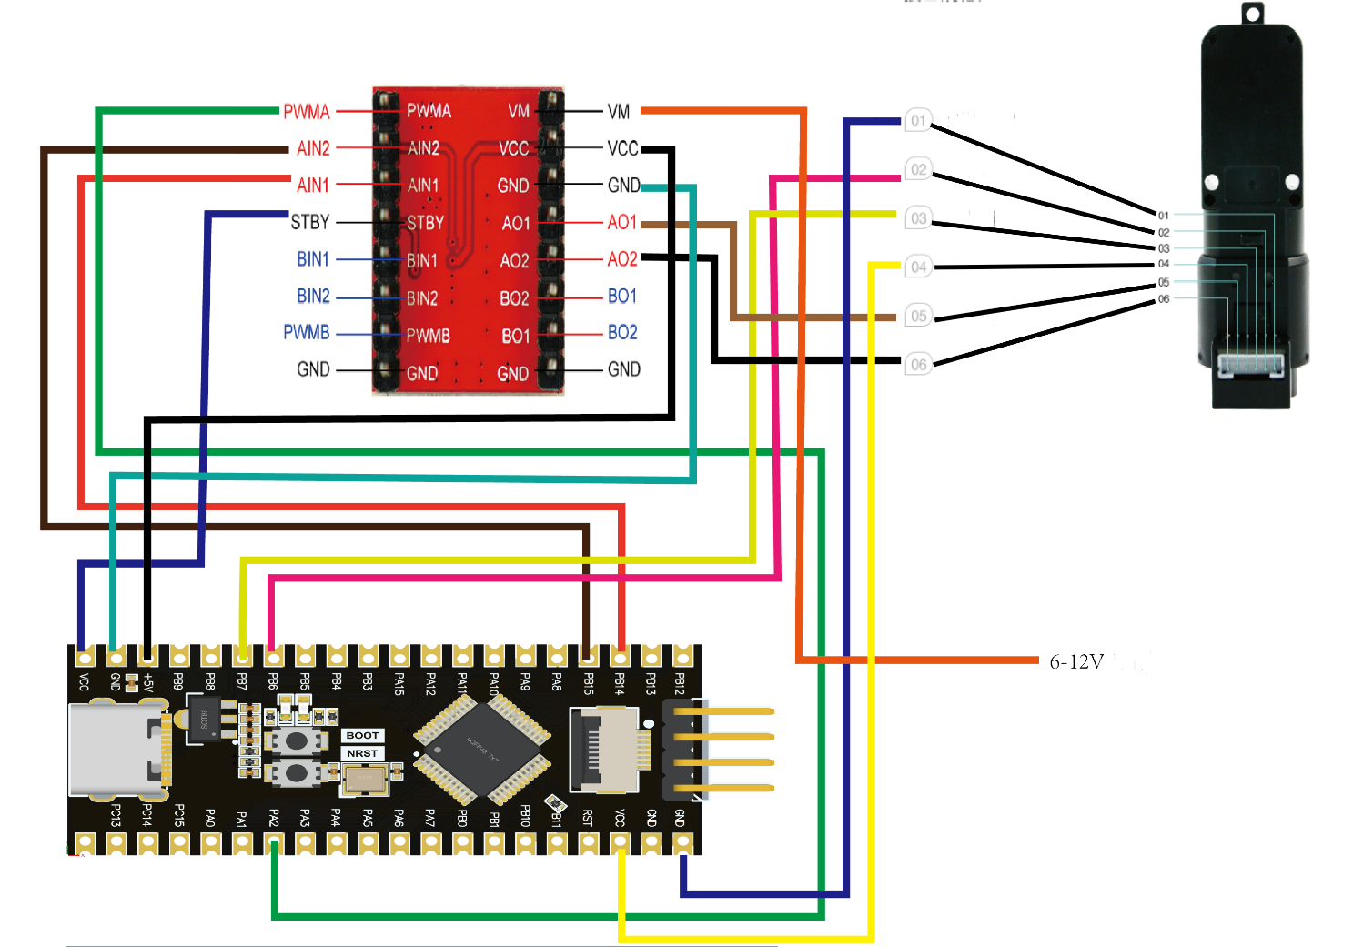

The hardware wiring diagram shows the STM32F103C8T6 wiring diagram, STM32F103RCT6 all wiring is the same, according to the corresponding pin connection.

·Hardware wiring：

TB6612 module AIN1 ----> PB14

TB6612 module AIN2 ----> PB15

TB661 module PWMA ----> PA2

TB6612 module STBY ----> STM32 5V

TB6612 module VCC ----> STM32 5V

TB6612 module VM ----> 6-12V power

TB6612 module GND ----> STM32 GND

TB6612 module AO1 ----> Motor M+

TB6612 module AO2 ----> Motor M-

TT Motor encoders A口----> PB6

TT Motor encoders B口----> PB7

TT Motor encoders VCC----> STM32 5V

TT Motor encoders GND----> STM32 5V

TTL Motor encoders TX ----> PB11 (STM32 RX)

TTL Motor encoders RX ----> PB10 (STM32 TX)

**3. 程序**

Initialize timers, pins, interrupts, etc.

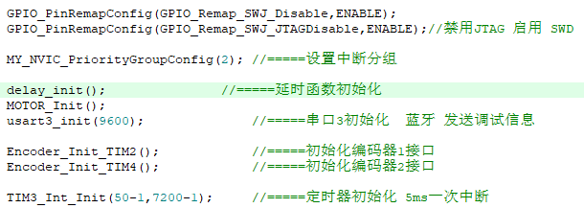

Drive the motor forward and print the speed value

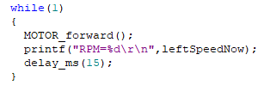

The program did two code disc speed measurement, respectively used T4 and T2 timers, in the main cycle only printed the T4 timer (revolver) speed measurement results, and arduino program, the speed test uses the current value minus the previous value to achieve forward and reverse judgment, here 20, 4.601 is the best ratio obtained after multiple actual speed tests.

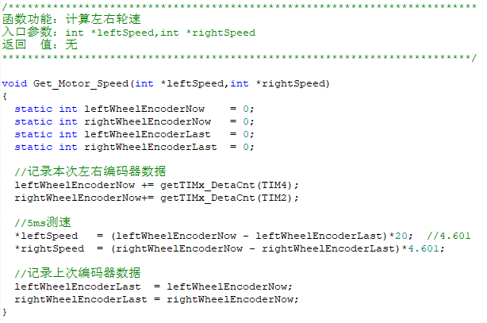

**4. Experimental phenomenon**

After the program is downloaded, run, the motor rotates, using the TTL level translation module, the baud rate is set to 9600, you can, check the corresponding motor speed on the computer.

